CANADA

Government

Canada is a federation of ten provinces (Alberta, British Columbia, Manitoba, New Brunswick, Newfoundland and Labrador, Nova Scotia, Ontario, Prince Edward Island, Quebec, and Saskatchewan) and three territories (Northwest Territories, Yukon, and Nunavut). Formally considered a constitutional monarchy, Canada is governed by its own House of Commons. While the governor-general is officially the representative of Queen Elizabeth II, in reality the governor-general acts only on the advice of the Canadian prime minister.

Geography

Covering most of the northern part of the North American continent and with an area larger than that of the United States, Canada has an extremely varied topography. In the east, the mountainous maritime provinces have an irregular coastline on the Gulf of St. Lawrence and the Atlantic. The St. Lawrence plain, covering most of southern Quebec and Ontario, and the interior continental plain, covering southern Manitoba and Saskatchewan and most of Alberta, are the principal cultivable areas. They are separated by a forested plateau rising from Lakes Superior and Huron.
Westward toward the Pacific, most of British Columbia, the Yukon, and part of western Alberta are covered by parallel mountain ranges, including the Rockies. The Pacific border of the coast range is ragged with fjords and channels. The highest point in Canada is Mount Logan (19,850 ft; 6,050 m), which is in the Yukon. The two principal river systems are the Mackenzie and the St. Lawrence.
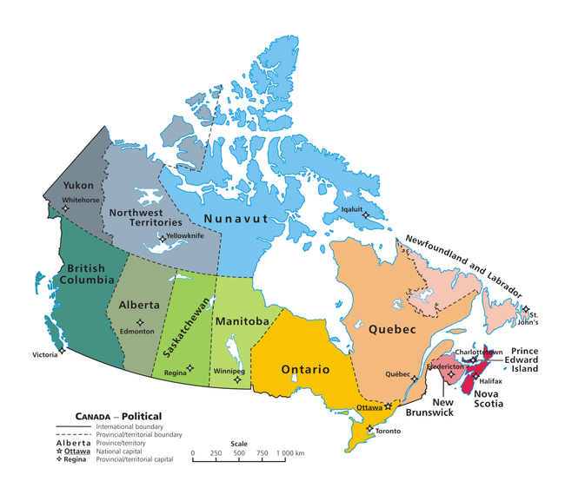
Sovereign: Queen Elizabeth II (1952)
Governor-General: David Lloyd Johnston (since 2010)
Prime Minister: Stephen Harper (since 2006)
Land area: 3,511,003 sq mi (9,093,507 sq km); total area: 3,855,102 sq mi (9,984,670 sq km)
Population (2012 est.): 34,300, life expectancy: 81.48; density per sq km: 3
Capital (2004 est.): Ottawa, Ontario, 1,170,000 (metro. area)
Largest cities (metropolitan areas) (2009 est.): Toronto, 5,377,000; Montreal, 3,750,000; Vancouver, 2,170,000; Calgary, 1,160,100; Edmonton, 1,101,600; Quebec, 710,700; Hamilton, 710,300; Winnipeg, 702,400; London, 459,700; Kitchener, 450,100

Language: Canada's two official languages are Canadian English and Canadian French. Approximately 98 percent of Canadians speak English or French: 57.8 percent speak English only, 22.1 percent speak French only, and 17.4 percent speak both

Economy: Canada is the world's eleventh-largest economy. Since the early 20th century, the growth of Canada's manufacturing, mining, and service sectors has transformed the nation from a largely rural economy to an urbanized, industrial one.

Použitá literatura:
Canada. [online]. [cit. 2013-03-03]. Dostupné z: http://www.infoplease.com/ipa/A0107386.html
Canada. In: Wikipedia: the free encyclopedia [online]. San Francisco (CA): Wikimedia Foundation, 2001- [cit. 2013-03-03]. Dostupné z: http://en.wikipedia.org/wiki/Canada

