BASIC INFORMATION OF THE USA
On all levels, the USA is a huge and important country dominating the North American continent. It consists of 50 states and is the home of over 300 million people of varied origin.
The following illustration shows the geographic division of the U.S.A. with the 48 contiguous states (excluding Alaska and Hawaii).
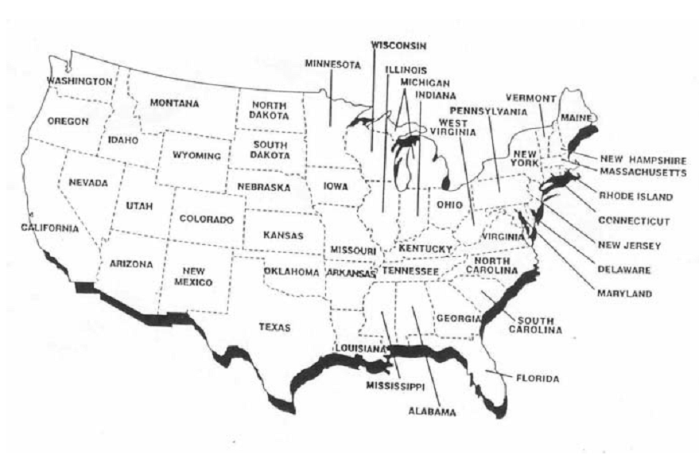

The United States of America (conventional short form is the United States, abbreviation U.S.A. or simply U.S.) is the fourth largest nation in the world in area after Russia, Canada and China. The total area of the U.S.A. is 3,600,000 square miles (= 9,629,091 km²) out of which 9,158,960 km² are taken up by land while 470,131 km² are apportioned to water areas.
The climate of the U.S. is mostly temperate, however, Hawaii and Florida are in the tropical zone, the climate in Alaska is arctic and the weather in the Great Plains west of the Mississippi River and in the Great Basin ranges from semiarid to arid.
The U.S. terrain consists of a vast central plain, mountains in the West and hills and low mountains in the East. The country’s elevation extremes are the following: the lowest point is the Death Valley, CA (-86m) while Mount McKinley, AK (6,194m) represents the highest point.
The US government type is a Constitution-based federal republic with a strong democratic tradition dating back into the 17th century.
The national holiday of the country is 4th July (Independence Day) commemorating the beginning of American independence. The legal system is based on English Common Law. Suffrage in the USA is universal and concerns citizens over the age of 18. The last presidential election took place on November 6, 2012.
From the point of view of economy, the USA is one of the leading world superpowers. The most widely grown crops are: wheat, corn and other grains, fruits, vegetables, or cotton. Among other agriculture products are beef, pork, poultry, dairy products, forest products, and fish.
Americans are particularly engaged in the production of motor vehicles, chemicals, electronics, and consumer goods, petroleum and steel processing, food processing, aerospace, telecommunications, lumber, and mining.
As for population, the United States once again occupies the fourth position in the world after China, India and Russia. According to the statistics from July 2011, the number of people living in the U.S.A. has reached more than 300 000 000 million.
When discussing the character of the inhabitants , diversity has to be mentioned.
Diverse means different, varied and diversity represents an inseparable part of the American society. Taking into account the size and the multi-national/racial character of the country, it would be absolutely irrational to expect to find exactly the same features throughout the whole U.S.A. In America, diversity is carried out on several levels:
- Ethnic/racial groups
- Geography
- Religion
- Climate (Change of 4 seasons, sub tropical, arctic
- Time zones (There are 6 time zones altogether in the U.S. – 4 in the 48 contiguous states plus 1 in Hawaii and 1 in Alaska.)

Použitá literatura
GABRIELLE SMITH-DLUHÁ A KOLEKTIV. Angličtina Otázky a odpovědi. Infoa, 2007. ISBN 978-80-7240-489-6.
HOLEŠOVÁ, Andrea. American Studies. Ostrava: Ostravská univerzita v Ostravě, 2004.
Spojené státy americké. In: Wikipedia: the free encyclopedia [online]. San Francisco (CA): Wikimedia Foundation, 2001- [cit. 2012-12-16]. Dostupné z: http://cs.wikipedia.org/wiki/USA

