TEST – UNITED KINGDOM
Answer these questions:
- What is the climate of the UK like? How is it influenced by the Gulf Stream and how does the climate influence the weather?
- Write the names of the main mountain ranges, rivers, lakes, archipelagoes and of the important cities (capitals, industrial centres) into the blank map of the British Isles that you have enlarged. Then compare it with a map in an atlas.
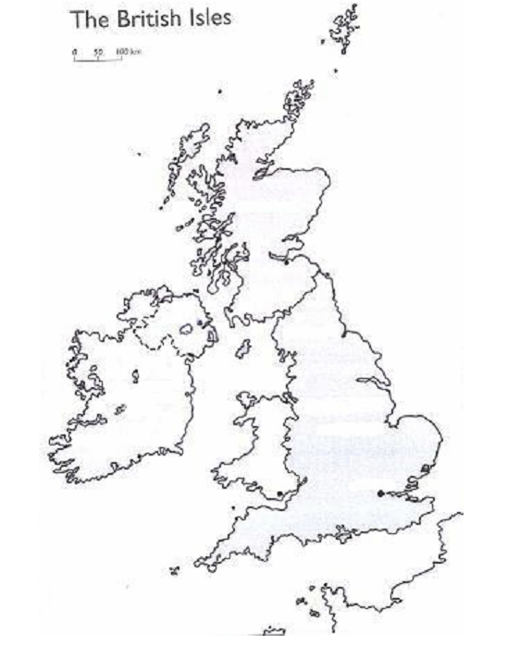

- Which are the major airlines, ports and airports in the UK?
- How did the structure of the British economy change in the 20th century?
- Can you find reasons for the changes?
- Which sectors of the economy
• are expanding?
• play an important role in the economy?
- Supply the required information:
  - The area of: Northern Ireland ………… Scotland ………… Wales …………
  - The three geographical areas of Scotland and their character:
1 ………………………………………………………………
2 ………………………………………………………………
- ………………………………………………………………

- Write the names of captials of
  - Wales
  - Northern Ireland
  - Scotland
and be ready to give more information
- Find out:
  - as much information as you can about one sight located in the City of London and one in the West End;
  - more information about Edinburgh, Glasgow, Cardiff and Belfast;
- How did the structure of the British economy change in the 20th century? Can you find reasons for the changes?
- Write some important events and people you know from British history
- Which are the chief manufacturing industries, and what do they produce?

Použitá literatura:
GABRIELLE SMITH-DLUHÁ A KOLEKTIV. Angličtina Otázky a odpovědi. Infoa, 2007. ISBN 978-80-7240-489-6.
NANGONOVÁ, Stella. Spojené království v roce 2006. 1. vyd. Ostrava: Ostravská univerzita v Ostravě, 2006.

